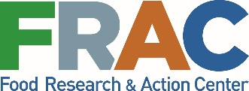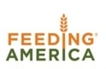

#SNAPtoEndHunger

Sign Up for the #SNAPtoEndHunger Thunderclap

Why?
The Supplemental Nutrition Assistance Program (SNAP) is the first line of defense against hunger in the U.S. This essential program that ensures millions of struggling Americans — including millions of children, seniors, people with disabilities, low-wage workers, and veterans — get the nutrition they need is under attack. We’re asking advocates to call on the Senate and House Agriculture Committees to strengthen and protect SNAP in the upcoming Farm Bill.

How it Works
Thunderclap is a platform that allows social media users to share the same message at the same time to create a lot of noise around an issue. Think of it as a virtual rally where anyone with a Twitter or Facebook account can participate.

- Sign up today at Food Research & Action Center and Feeding America’s Thunderclap Campaign page and choose how you’d like to share the message, either via your Facebook or Twitter account.
- Authorize access to your account so Thunderclap can post the message for you automatically. No worries, it is completely secure.
- Thunderclap will schedule the one-time post to be delivered simultaneously with other advocates’ posts at 10 a.m. EST on February 27.
- The virtual thunderclap will echo the efforts of hundreds of ant-hunger advocates who will be storming Capitol Hill that day as part of the National Anti-Hunger Policy Conference.

That’s it! With two clicks, you can help make a lot noise and capture the attention of Congress.

